**TOURISM MANAGEMENT SYSTEM**

|  |  |  |
| --- | --- | --- |
| **CHAPTER No.** | **Content** | **Page No.** |
| **1** | **Introduction**  **1.1 Problem Statement**  **1.2 Description** | **2** |
| **2** | **Requirements**  **2.1 Scope**  **2.2 Objectives**  **2.3 Project outcomes**  **2.4 Functions Used** | **4** |
| **3** | **Test Plan** | **6** |
| **4** | **Test Cases** | **9** |
| **5** | **Expected results** | **10** |
| **6** | **Conclusion** | **11** |
| **7** | **References** | **12** |

### **1. INTRODUCTION**:

### In today's world, tourism has taken its place as one of the major sources of foreign exchange for both developed and developing economies. Therefore, efficient management of tourists and tourism has become important in accessing the benefits accruing from this sector of the world economy. Tour management system is a dynamic website for tourism business. It is a dynamic and responsive web design. It is also called travel technology solution for agencies and tour operations. Nearly everyone goes on a vacation for this ‘Tourism management System’ would play a vital role in planning the perfect trip. This project allows the user of the system access to all the details such as location, places, view tour-brochures etc. The system can be used for both professional and business trips. The proposed system maintains a centralized repository to make necessary travel arrangements for tour and retrieve information easily. Tourists are more attractive for the cultural diversity of the world. The project presents the overall design of the tourism group management system and the working principle, and then describes the design of the software of the system in detail, as well as introduces the software design flow of the system.

**1.1 PROBLEM STATEMENT**: Tourism management system is developed in C programming for the users to book the tour tickets for trips, viewing tourism brochures etc.

**1.2 DESCRIPTION:**

The Tourism Management System is based on a concept of maintaining tour packages for the tourists. Before stepping into the main system, a user has to pass through the login system to get access, then only he/she can use the features of the system which includes booking package, previewing ticket, cancelling a ticket, viewing tourism brochure. It also contains a sign-up feature.

Talking about the features of the Tourism management system, a user needs a certain id to get access. For this, the user can simply sign up by providing username and password. After logging in as a user, there are several options to perform. The user can check for holiday packages and book. In order to book a package, the user has to select within given package details and enter the number of people. After the booking is done, he/she can check for the ticket details which displays the total price and ticket of the package. In total there are 10-holiday packages. Whenever the user wants to cancel the tickets, he/she can easily cancel it and get the refund.

There are certain things like a user can only book one package from one user id. In order to book more packages, he/she needs to cancel their current bookings. Each package contains a unique code, which the user must enter during booking procedures. The last feature of this project is about changing the password. A user can change his/her password anytime just by providing their current password (to verify user) and entering a new password. After all these, the user can also log out of their current id. The system creates an external file to store the user’s data permanently.

Tourism Management system is developed using C Programming Language and different variables, strings have been used for the development of it. This project provides the simplest system for managing tour packages for the tourism sector.

**Features:**

1. Sign up

2. Login-Logout

3. Book Tour Package

4. Check Tickets

5. Cancel Tickets

6. Change Password

7. Brochure.

**2. REQUIREMENT ANALYSIS:**

**2.1 SCOPE:**

Tourism Management System is an integrated software developed for tour operating companies. The main aim of this project is to help the tourism companies to manage their customers, tour-tickets. It makes all operations of the tour company easy and accurate. The standalone platform makes tourism management easy by handling agencies requests and providing servers for the customers located at different parts of the various cities. Different modules have been incorporated in this project to handle different parts and sectors of the tour management field.

**2.2 OBJECTIVES:**

* The Tourism management system is a web-based application and maintains a centralized repository of all related information. The objective of this project is to develop a system that automates the process and activities of a tour agency and customer details. The purpose is to design a system using which one can perform all operations related to traveling and book tickets and sightseeing.

**2.3 PROJECT OUTCOMES:**

* This system will connect directly to customers and agents through the internet.
* This system helps to make a strong relationship with customers so that they can enjoy their holiday of their dreams.
* This system helps to develop tourism with different cultures so that they enrich the tourists experience and build pride.
* This system will provide a display platform in which tourists can find their tour places according to their choices.

**2.4 FUNCTIONS USED:**

**1.Add User**-This function is used to add the new user/customer. To add the new record, it requires the username or email-id and password.

**2**.**Login User**-This function is used to login for customers. This list has various attributes like username or email-id and password.

**3**. **Tour Brochure** -This function is used to see all tour packages and their costs by clicking the tour location codes

**4.Exit**- This function is used to exit from the website by pressing any key.

**HARDWARE REQUIREMENTS:**

* Processor-At least 2.0 GHZ
* Ram-4GB

**SOFTWARE REQUIREMENTS:**

* Operating system-Windows
* Programming language- C
* Editor tools: Dev c++, code blocks ide,C compiler.

**3.TEST PLAN:**

**Features to be tested:**

|  |  |
| --- | --- |
| **MODULE** | **DESCRIPTION** |
| To add the users to the list | The users can be added to the list by entering the username/email and the password. |
| To login the users | The users are allowed to login by entering their username and password which they have created. |
| To view the tour-brochures | The available data of tour locations, tour packages and their costs can be done by clicking the tour location codes. |
| To check the tickets | The users can check their tickets by entering their username and password and tour location code. Then the user can check his ticket for his tour. |
| To cancel the tickets | The user can also cancel his ticket by entering attributes like username, password and tour location code. |
| To change password | The user can also change his password by entering his new password. And the new password is successfully updated. |

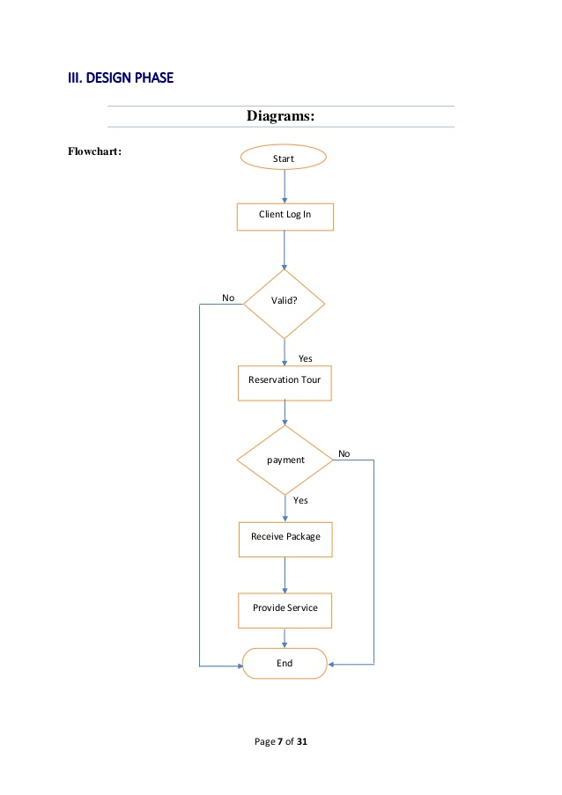

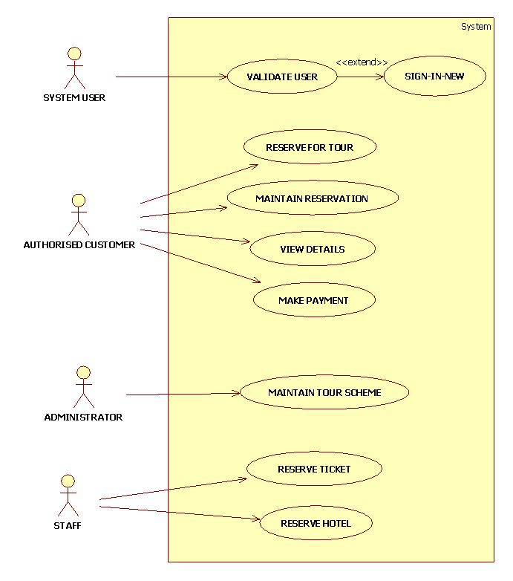

**4.TEST CASES:**

|  |  |  |  |
| --- | --- | --- | --- |
| **TEST CASE** | **TEST SCENARIO** | **TEST DATA** | **RESULT** |
| **1** | * To add the new user | (Enter ‘1’ for Adding the new user).  1.User Name/email-id: abc  Password:abc@123  2.User Name: def  Password:def@123 | User-ids are added successfully. |
| **2** | * To login the added user. | (Enter ‘2’ for login the user)  Press any key of choice  1.Book Package  2.Check Ticket  3.Print Ticket  4.Cancel Ticket  5.Logout user  6.Tour brochure  7.exit | Username Password  ------------------------------------------ abc abc@123  def def@123  Login successful  1.Packaged booked  2.TOURISM TICKET  ===============  Username/Email ID: abc  Tour Code: LL  Ticket Cost: Rs 120000.000000  Number of tickets: 5  Total Cost: Rs 600000.000000 |
| **3** | * Brochure-To see the tour places | (Enter ‘3’ for seeing the brochure.)  1. LL - Antelope Canyon Tours - Rs 40000  2. JK - Grand Canyon Local Tours - Rs 60000  3. SK - San Francisco Local Tours - Rs 25000  4. SHM - Miami Vacation - Rs 38000  5. AND - Hawaii - Rs 120000  6. BHB - Atlanta Vacation - Rs 10000  7. AG - San Francisco - Rs 30000  8. ND - Alaska Vacation - Rs 32000  9. RJ - Orlando Vacation - Rs 45000  10. SI - South US Tour - Rs 250000 | 1)Enter place code (eg: LL, JK)  LL  Would You Like to Confirm Booking?  [1] - Yes  [2] - No  1  Enter the number of tickets you want to book?  2  Bookings Done!!  2)Enter place code (eg: LL, JK)  JK  Would You Like to Confirm Booking?  [1] - Yes  [2] - No  1  Enter the number of tickets you want to book?  2  Bookings Done!! |
| **4** | * Exit | (Enter ‘4’ for exit/quit) | **Exiting...** |

**5.EXPECTED RESULTS:**

|  |  |
| --- | --- |
| **TEST CASE ID** | **Expected Result** |
| **1** | Users are successfully added. |
| **2** | Username Password  ------------------------------------------  abc abc@123  def def@123  Login successful |
| **3** | Username Password  ------------------------------  abc abc@123  def def@123  Enter place code (eg: LL, JK)  JK  Enter the number of tickets you want to book?  2  Bookings Done!! |
| **4** | Exiting…. |

**6.CONCLUSION:**

Tourism is currently recognized as a global industry which is highly growing at a high rate like other industry. There are many different activities that are occurred in tour activities. My ‘Tourism Management System’ is a software application helps in online distribution of tour packages along with their costs. This project can be fully customized with integration of different API’s.It has friendly environment that connects the customer willingly. Finally, i can say that this is a software-based application which will help users to control and handle the tour related activities effectively and efficiently.

**7.REFERENCES:**

1)International Journal of Engineering Research & Technology (IJERT**)-**

Design and Development of Tour Management System using Android.

2)American Scientific Research Journal for Engineering and Technology and sciences-Intelligent Tourism Management System by Ernest E. Oinuri.

3)IEEE paper-Management of tourism group and technology of the personalized tour based on RFID by Wentao Huang.